**CODING CHALLENGE PYTHON**

**NAME- PUJAN RASTOGI**

**Explain Pandas for Data Processing & execute Reading CSV Data using Pandas**

Pandas is a Python library for data manipulation and analysis. It provides data structures like Series and DataFrame, along with a wide range of functions to efficiently manipulate, analyze, and visualize data. Pandas is particularly useful for working with structured data, such as tabular data, in various formats.

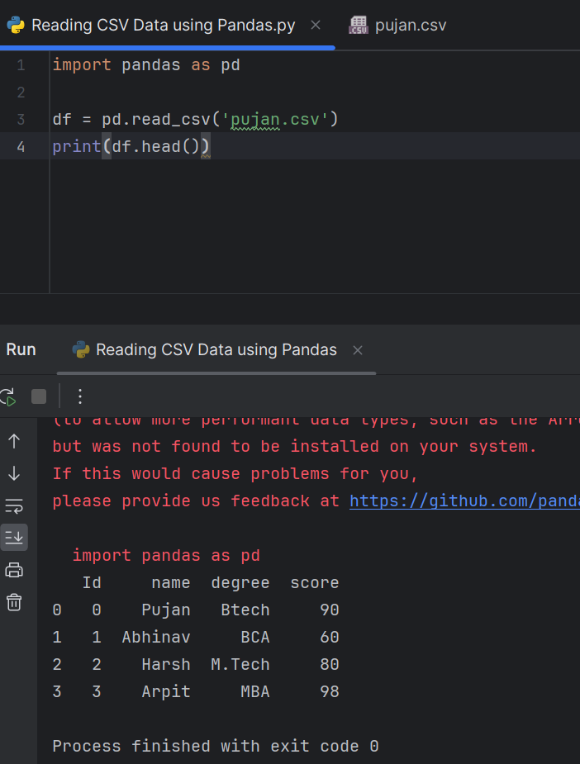

CSV FILE CREATED

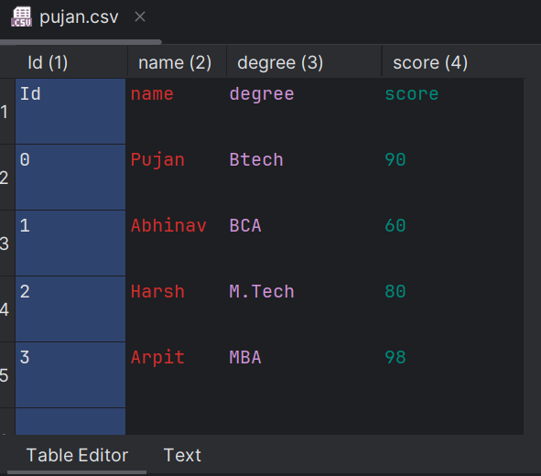

**Read Data from CSV Files to Pandas Dataframes**

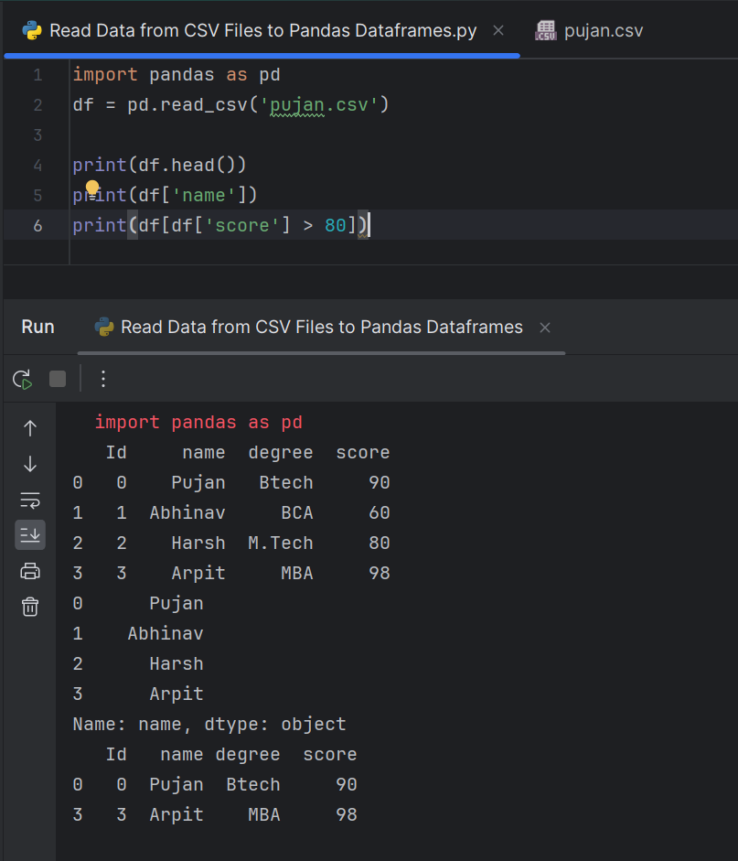

**Filter Data in Pandas Dataframe using query**

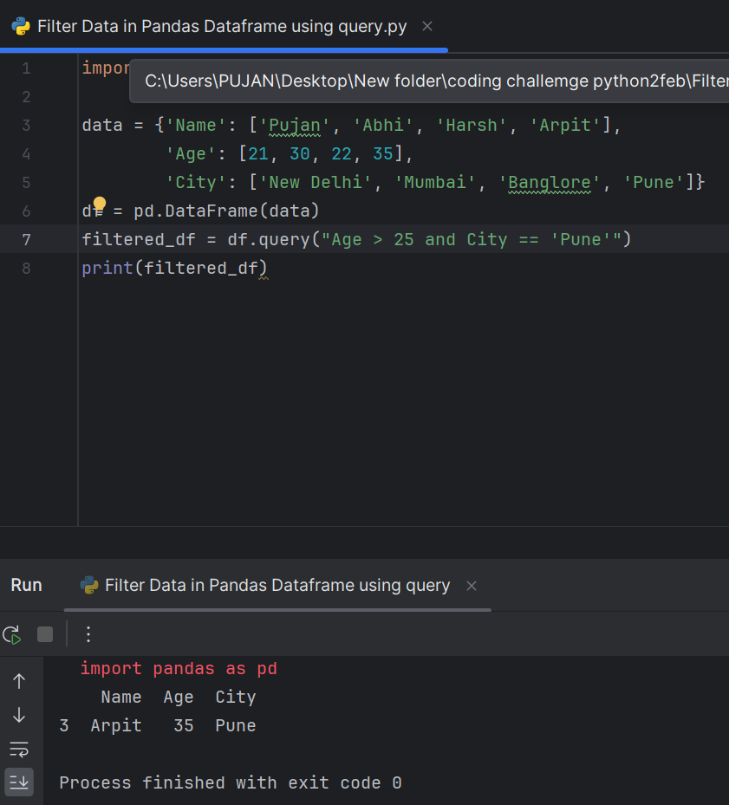

**Execute with one example Lambda Functions in Python**

Lambda functions are similar to user-defined functions but without a name. They're commonly referred to as anonymous functions. Syntax - lambda argument(s) : expression

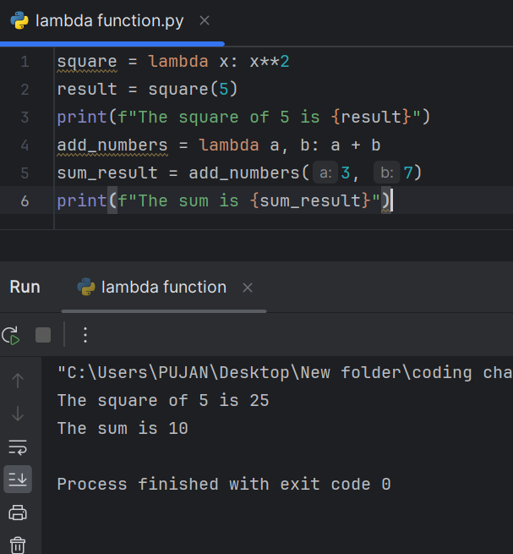

**Read JSON Strings to Python dicts or lists**

